**Catering Industry**

**Stakeholders**

|  |  |
| --- | --- |
| **ACTOR/stakeholders** | **What they can do on the software created** |
| Employees | Browse menu, Order Meal, Submit Feedback |
| Canteen Manager | Create Menu, Update Menu |
| Delivery Boy | Update Delivery Status |
| Management | Fetch Reports , Analyse Reports |
| Payroll System | It will handle the deductions which directly gets deducted from employee’s salary |

**Problem Definition and Solution**

**Problems**

* Lot of time is wasted, majorly 30-35 minutes were wasted in waiting in a queue to collect their food and get a table to sit and eat. However, the time spent eating was barely 10-15 minutes.
* Employees don’t always get their choice of food they want because the canteen runs out of certain items.
* The canteen wastes a significant quantity of food by throwing away what is not purchased.

**Solution**

* **Canteen Ordering System**

**Advantages and Objectives**

Advantages of the Canteen Ordering System:

* A system would save considerable time to those employees who use the service.
* It would increase the chance of them getting the food items they prefer.
* This would improve both their quality of work life and their productivity.
* The food wastage will be reduced.
* This will reduce the cost.

**Objectives:**

**Business Objective 1:**

Reduce canteen food wastage by a minimum of 30% within 6 months following first release.

Scale: Value of food thrown away each month by examining the canteen inventory

* Previous - 25% wasted
* Must plan for: Less than 15%

**Business Objective 2:**

Reduce canteen operating costs by 15% within 12 months, following initial release.

**Business Objective 3:**

Increase average effective work time by 30 minutes per employee per day, within 3 months.

**Business Objective 4:**

By making the ordering process automated and by delivering the food to the user's workstation, the canteen will be able to operate with lesser manpower.

**Existing System**

There is no existing system. The process is manual currently. It is very time consuming, lot of time wastage, wastage of food, employee productivity is hampered.

**Proposed System**

Proposed system is an automated software for ordering meal, tracking and updating menu, fetching report .

**

**Scope using *context diagram***

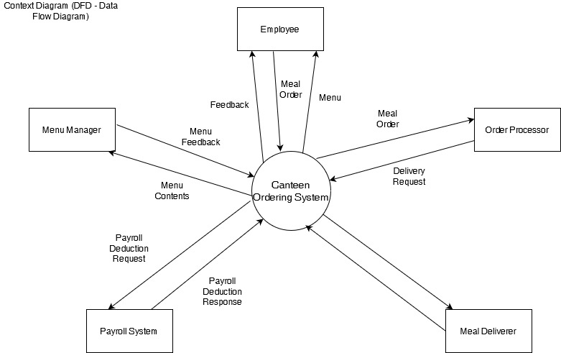

**In Scope**

* Login
* Create Menu
* Update Menu
* Delete Menu
* Fetching Reports

**Out of Scope**

* Delivery outside campus.
* Payment will not be done through any payment modes .

**

**Business Requirements:**

**1:** Reduce canteen food wastage by a minimum of 30% within 6 months following first release.

Scale: Value of food thrown away each month by examining the canteen inventory

* Previous - 25% wasted
* Must plan for: Less than 15%

**2:** Reduce canteen operating costs by 15% within 12 months, following initial release.

**3:** Increase average effective work time by 30 minutes per employee per day, within 3 months.

**4:** By making the ordering process automated and by delivering the food to the user's workstation, the canteen will be able to operate with lesser manpower.

**Functional Requirements**

* Login
* Create Menu
* Update Menu
* Delete Menu
* Fetching Reports

**Nonfunctional Requirements**

* Scalability
* Usability --- user friendly, navigation
* Performance--- The page should load in 2 secs

**System Requirement:**

**Web Version** Windows version ( 7 ,8 ,10 ,11)/ Mac iOS, Minimum 4GB Ram, 256 GB HDD/SSD, 32 Bit operating System

**App Version** Android version 6 and above and all iOS versions

**Usability:** Web and Application

**Environments:** Minimum 2mbps internet connectivity required

**Wireframes**

**Menu Creation**

**Order Menu**

